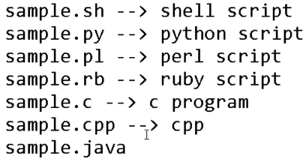

* Shell scripting treats like commands
* Programming language includes compilation as well. Programming language compiles the code and then they execute it
* Whereas interpreter executes the commands line by line
* In Linux, the interpreter stores in/bin/sh location.

In shell script file, we need write the first line as below which is default location of shell

* **#!/bin/sh**

If we give **which bash** command, we can find the location of bash

* This line is also called as shebang line. It is not mandatory to provide that line, it will take by default as shell
* If we are using any other like python, then we need to mention as **#!/bin/python**

**Example of adding two numbers:**

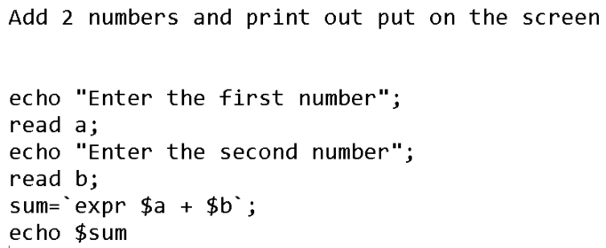

* As above, **a** is a variable which will be value entered by user
* And we are adding them with **expr** which is used for arithmetic operations
* And then we are printing the sum value
* We need to give space between + and a for the correct output
* “ “ are optional for echo

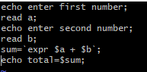

* This is the interactive way; we are entering the values. If we want in non-interactive way, we can pass the values in command itself as below

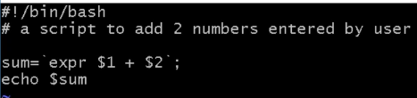

* As above, $1 and $2 are the arguments

We need to pass the values along with the script command as below

* **./sum.sh 10 20**

This will give output as 30